**“Inspect HTML”**

**- open web page then show the inspect the flag appeared as comment in HTML code:**

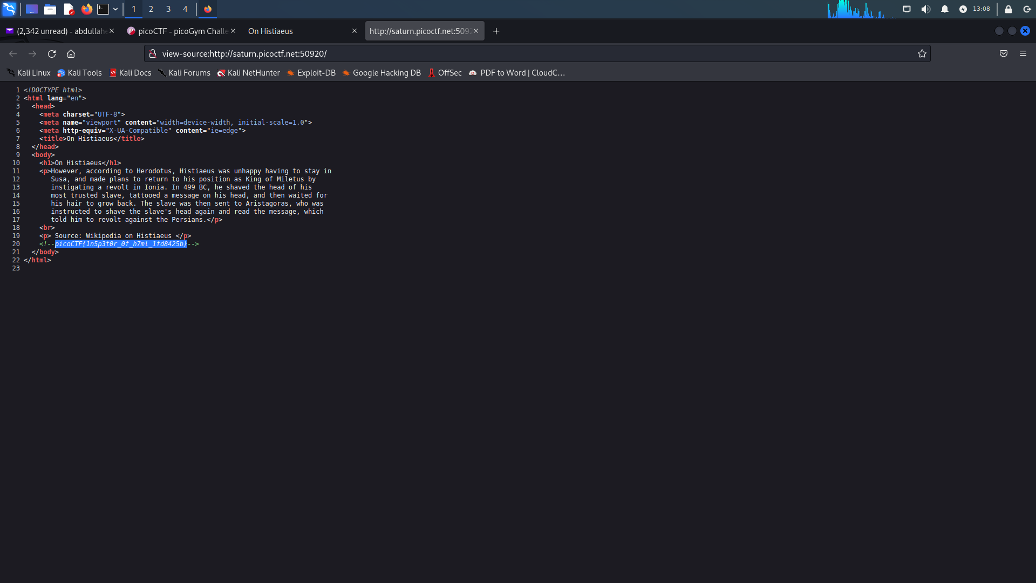

**“Files types”**

* Download flag file from the website picoctf.
* Try to open file but the file didn’t open.
* know the type of file by order “file” in kali.
* know that it contains bash, archive and text.

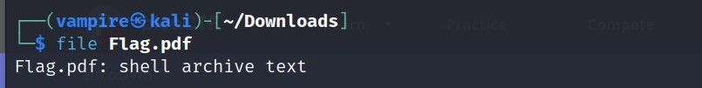

* Use “sh flag.pdf” in kali.

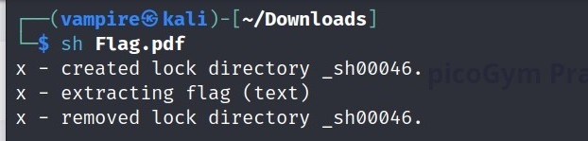

* Then know the bash file after open it write with tool and installed this tool.
* Use order “file flag” again to check the file type the file become archive and text.

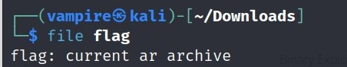

* 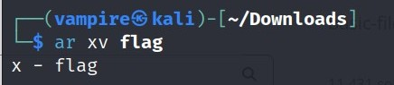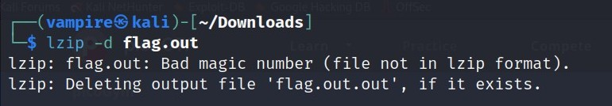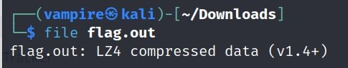Use many tools like cpio, rar, lzip, lz4, lzma and so on to decompress and extract file.
* Finally file flag become text it contains a hex code.
* 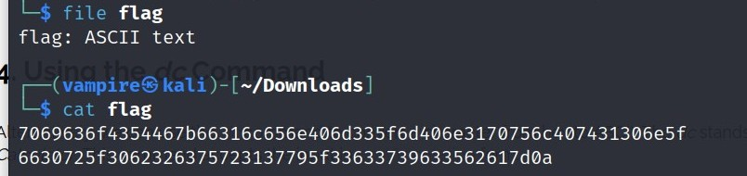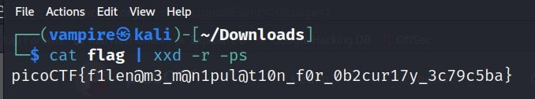Decrypt it by: xxd tool then get the flag.

**“enhance”**

1- Download file from picoctf.

2- use gedit tool in kali linux to catch flag

3-the flag: picoCTF{3nh4nc3d_aab729dd}

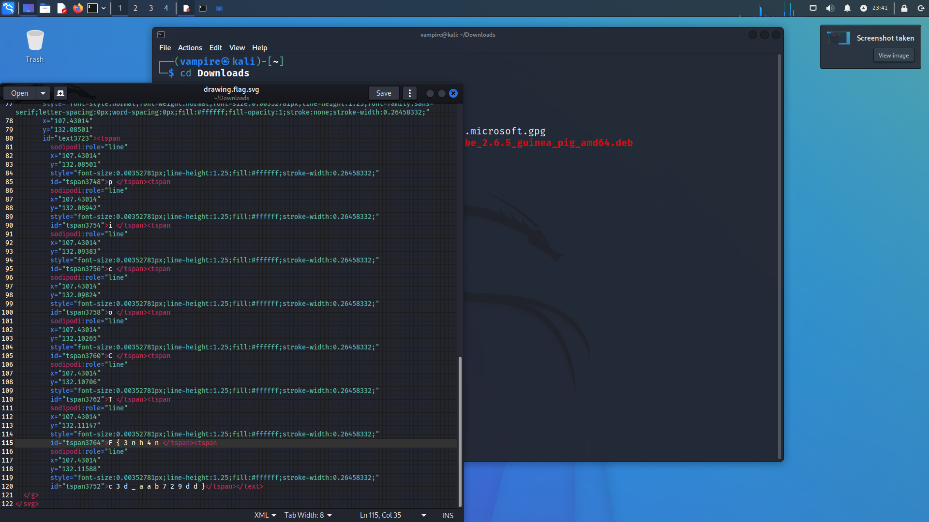

**“File-run1”**

- Download from terminal in kali Linux: “wget <https://artifacts.picoctf.net/c/308/run>”

- Change the permission of file to make it executable by “chmod +x run” (+x: make all executable file)

- Can’t open the file because it is executable file.

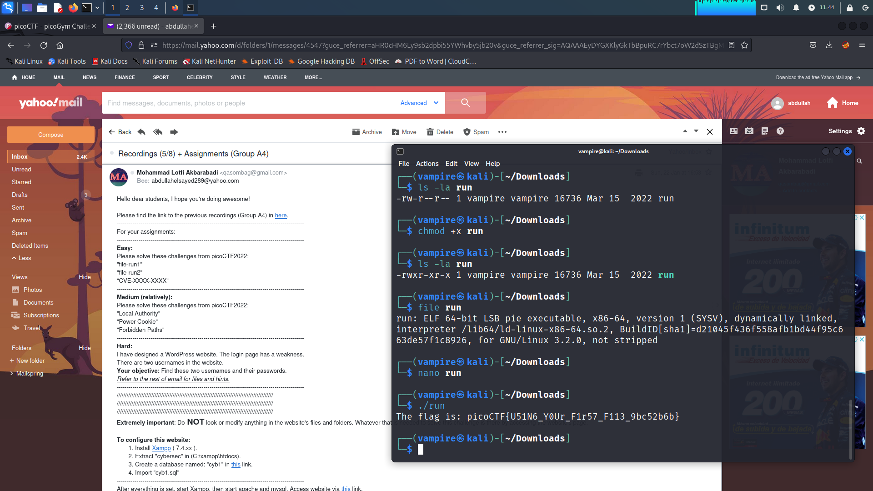

- Open the file with “./run”



**“File-run2”**

- Download from terminal in kali Linux: “wget <https://artifacts.picoctf.net/c/351/run>”

- Change the permission of file to make it executable by “chmod +x run” (+x: make all executable file).

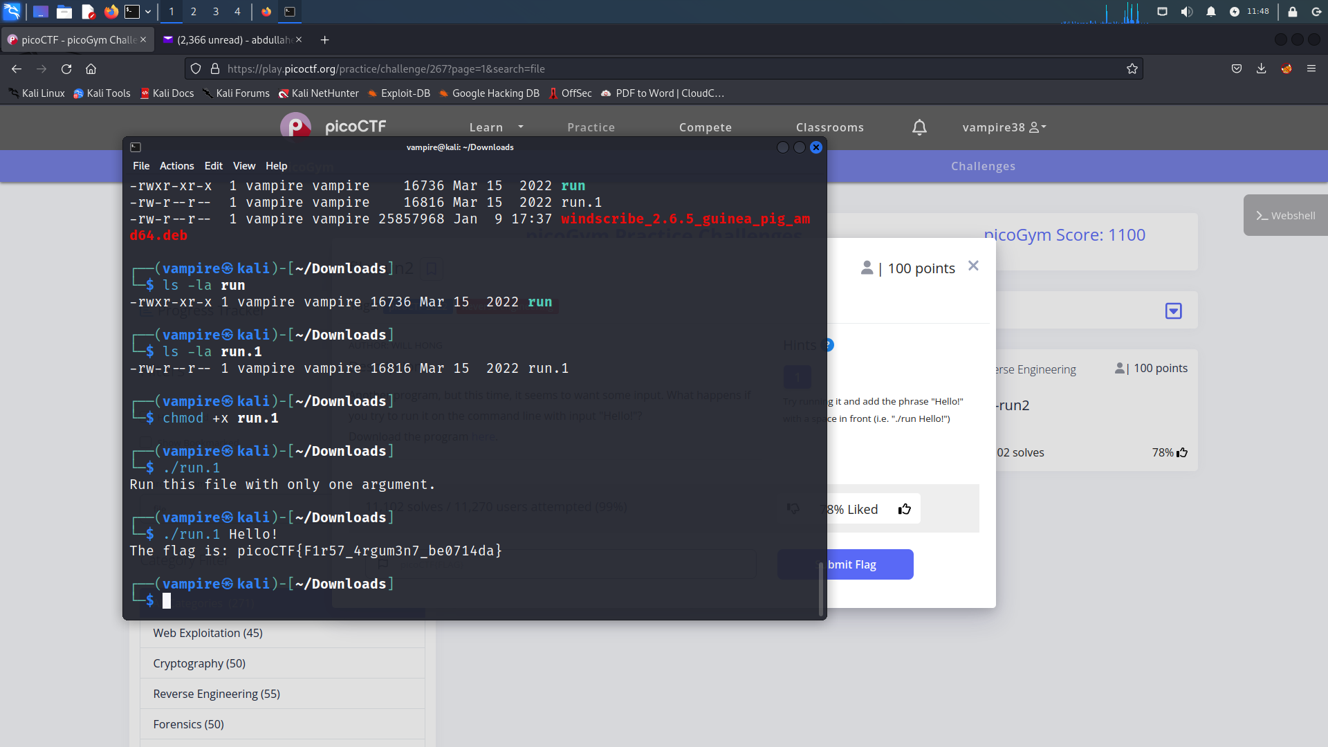

- Can’t open the file because it is executable file.

- Open the file with “./run Hello!” and get the flag.

**“CVE-XXXX-XXXX”**

- Search on CVE in google remote code execution (RCE) vulnerability in 2021 in the windows print spooler service, find the vulnerability.

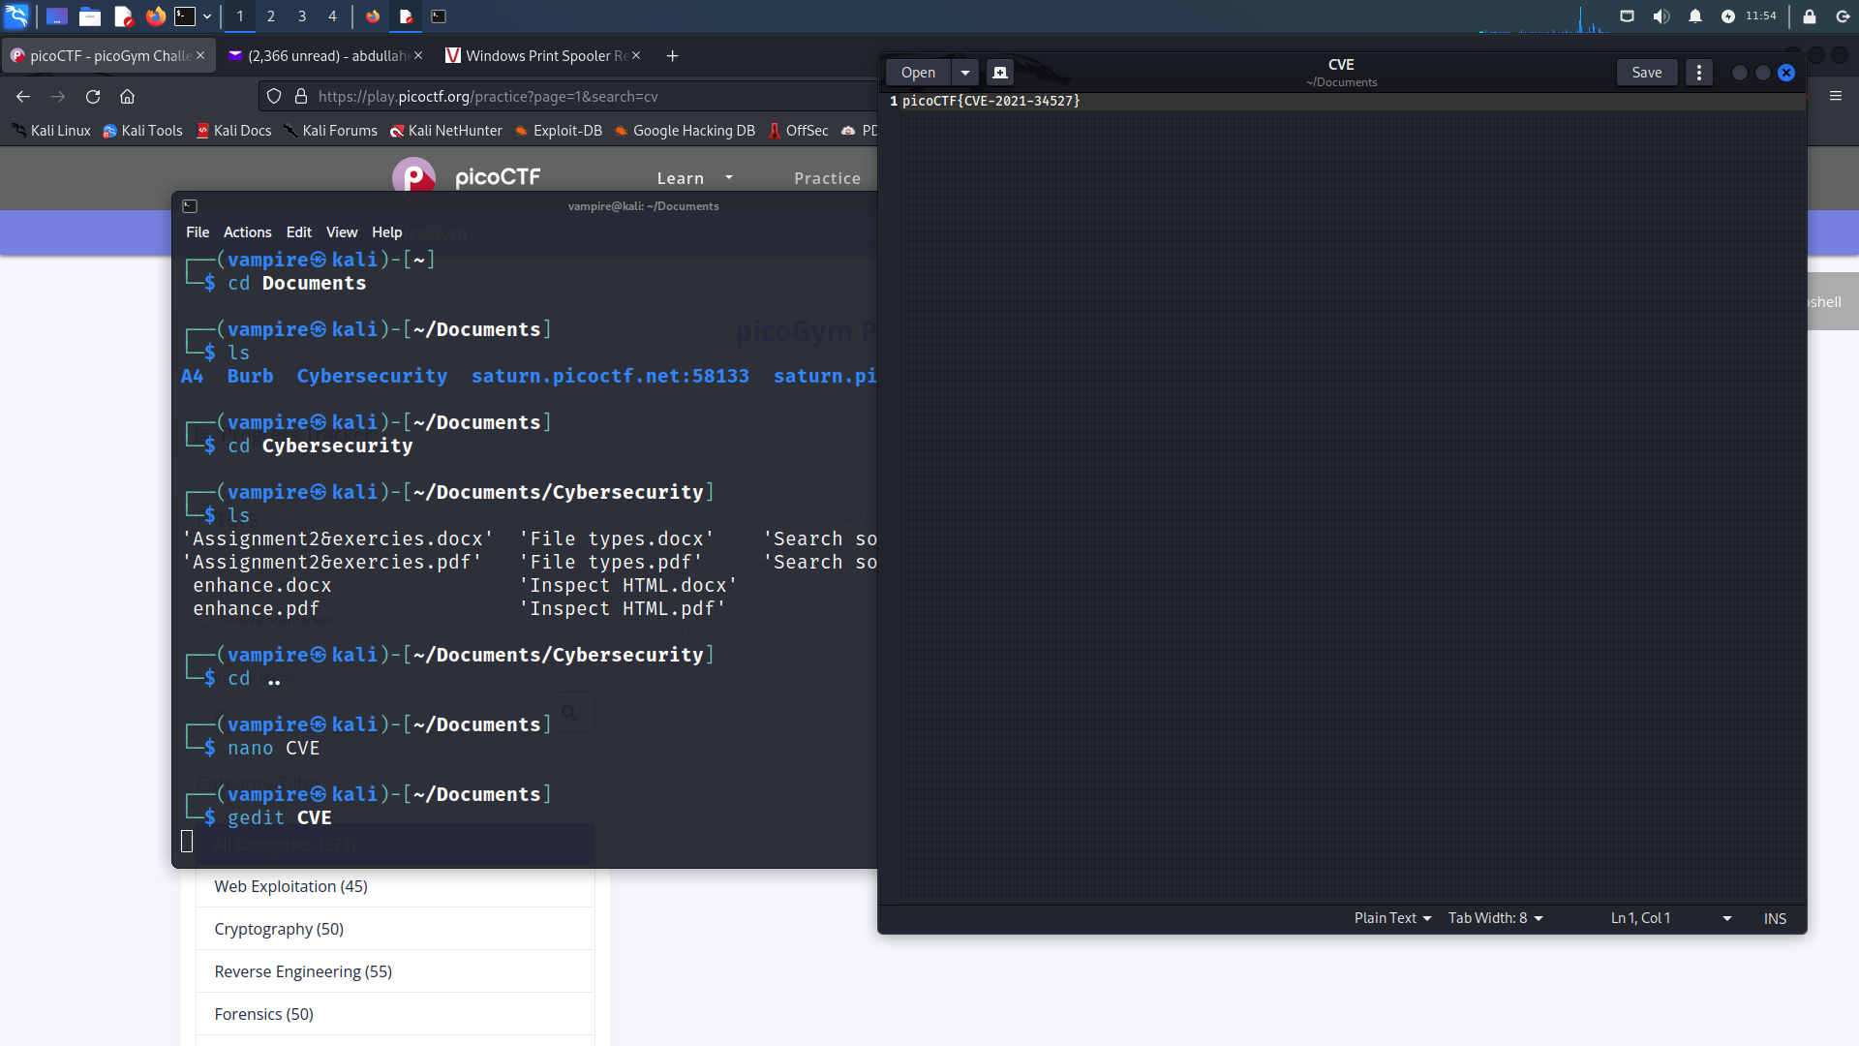- Write the vulnerability with the same form of flag.

**“Local Authority”**

- Open website from link “<http://saturn.picoctf.net:49699/>” .

- Try to input any username and password like as:

* username: admin password: pass

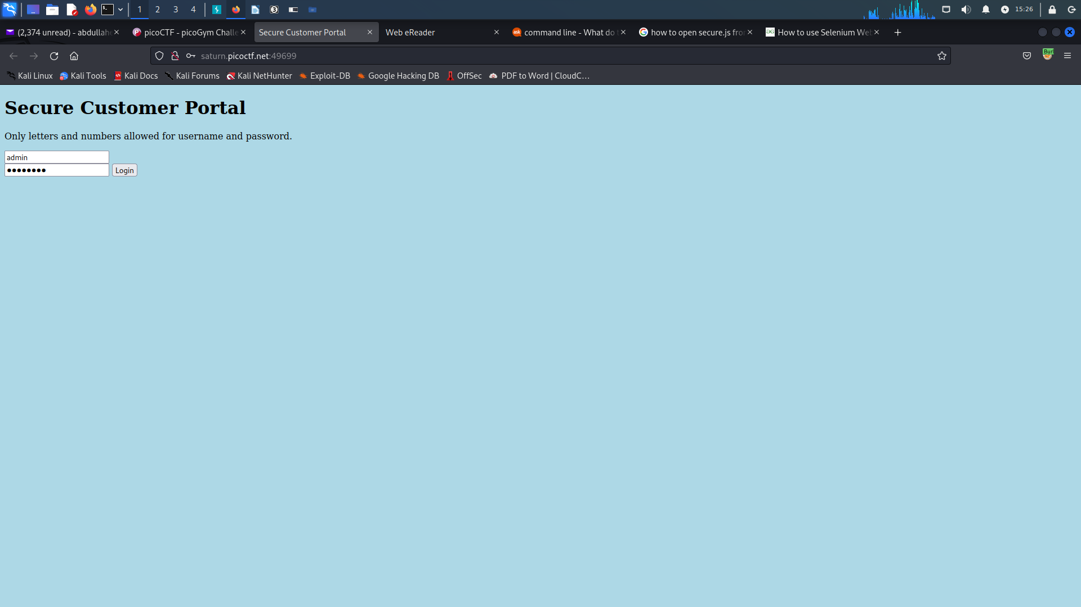

- Press on inspect (Q), then enter to debugger window show 2 file:

* login.php
* secure.js

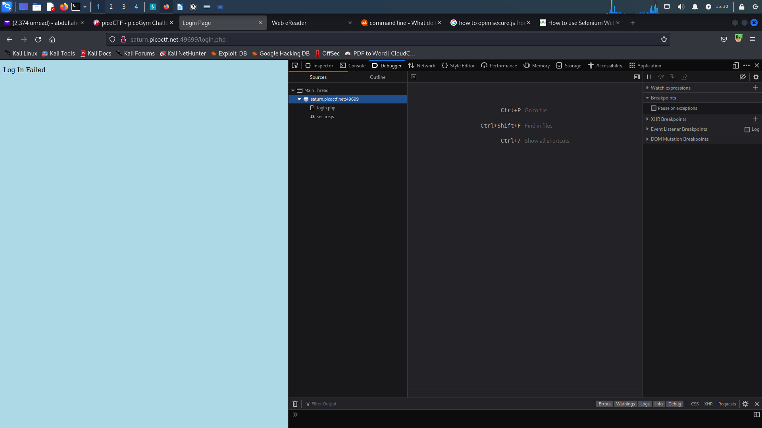

- Enter to secure.js, I will be found function for check password contain to real username and password.

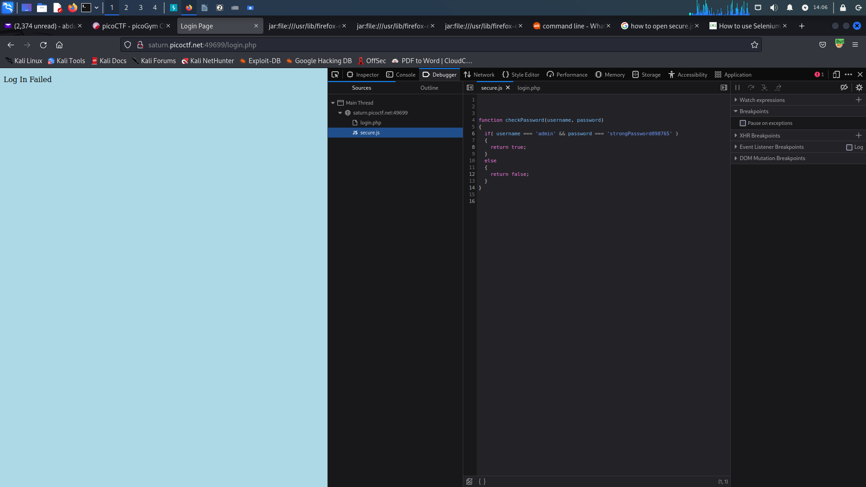

- Write username and password in login page then I will get the flag after login successful messag:

* picoCTF{j5_15_7r4n5p4r3n7_05df90c8}

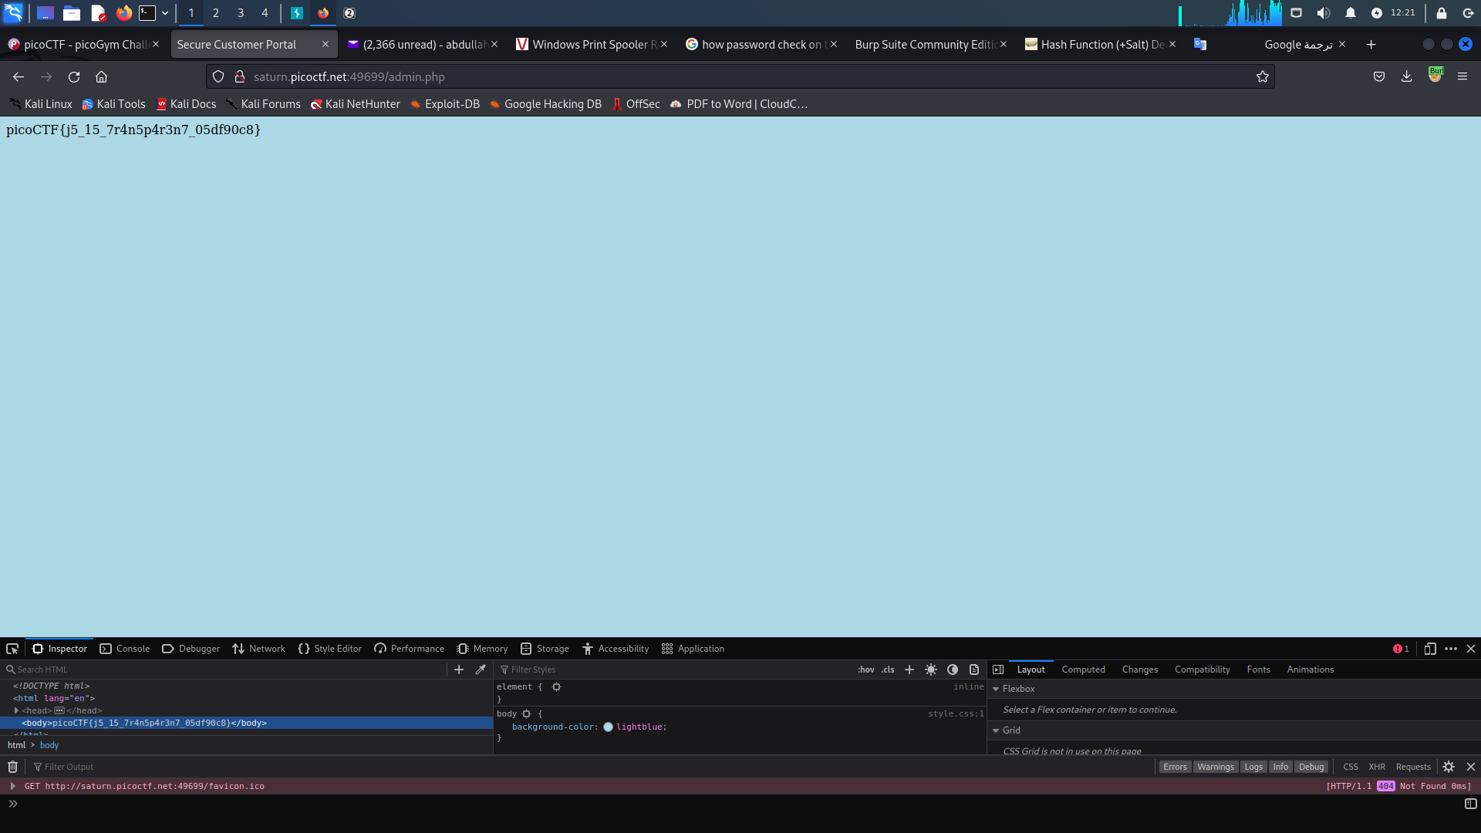

**“Power Cookie”**

- Open the link “<http://saturn.picoctf.net:55287/>” to enter website

- Click continue as guest.

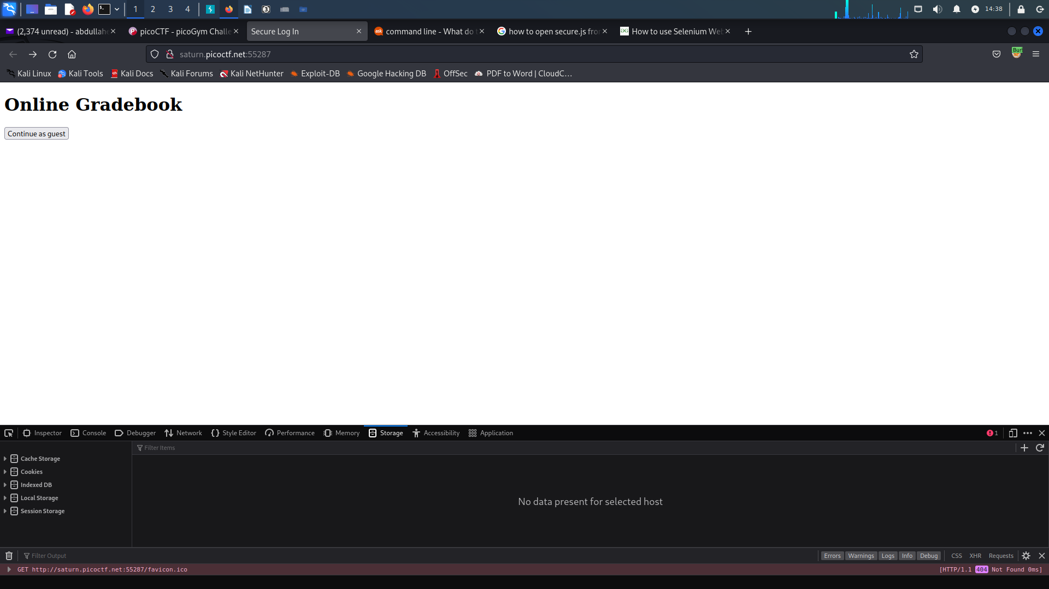



- Press on inspect (Q), enter to storage window and click on cookies. Change the value of isAdmin fr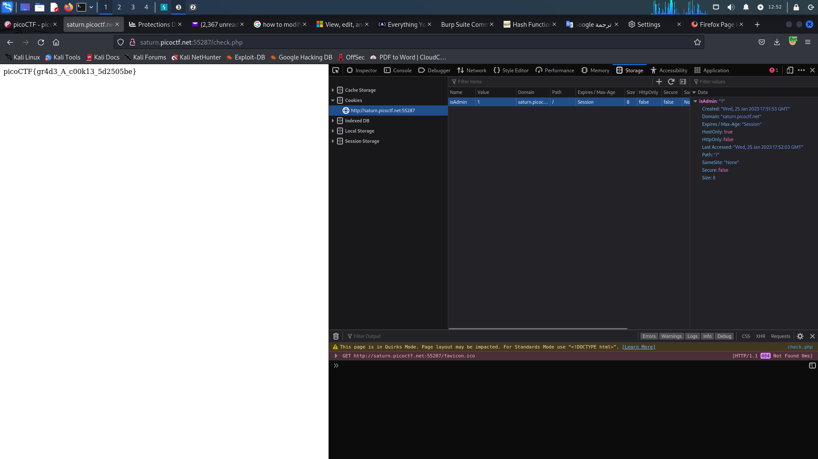om 0 1 as figure:



- Reload website a gain and I will get the flag:

* picoCTF{gr4d3_A_c00k13_5d2505be}



**“Forbidden Paths”**

- Enter to the website through the link “<http://saturn.picoctf.net:49700/>”

- Enter “../../../../../flag.txt” in search bar then press to read.

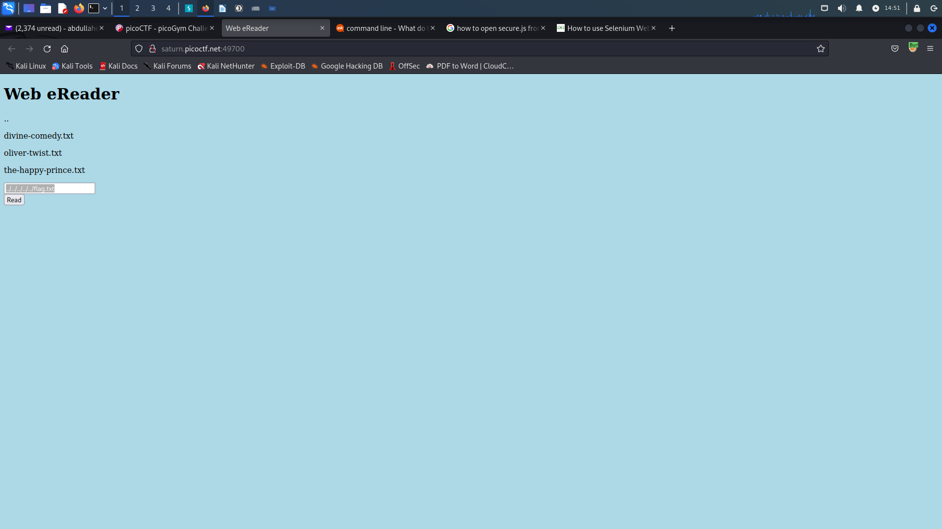

- Found the flag:

* picoCTF{7h3_p47h_70_5ucc355_6d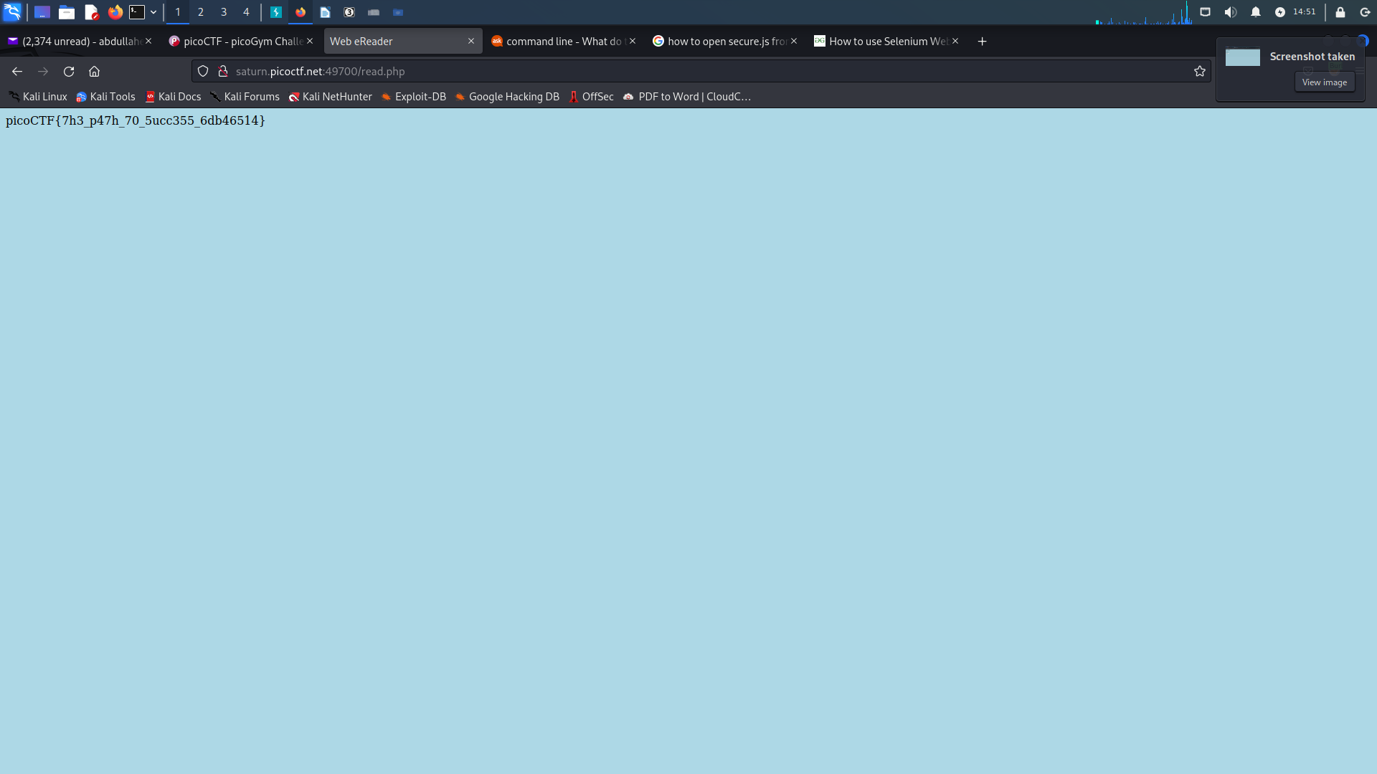b46514}

**“Search source”**

**1- First way:**

- open terminal in kali Linux and write “wget -m <http://saturn.picoctf.net:58133/>”

- open folder saturn.picoctf.net in vscode.

- use ‘grep’ tool in terminal of vscode to get the picoctf flag

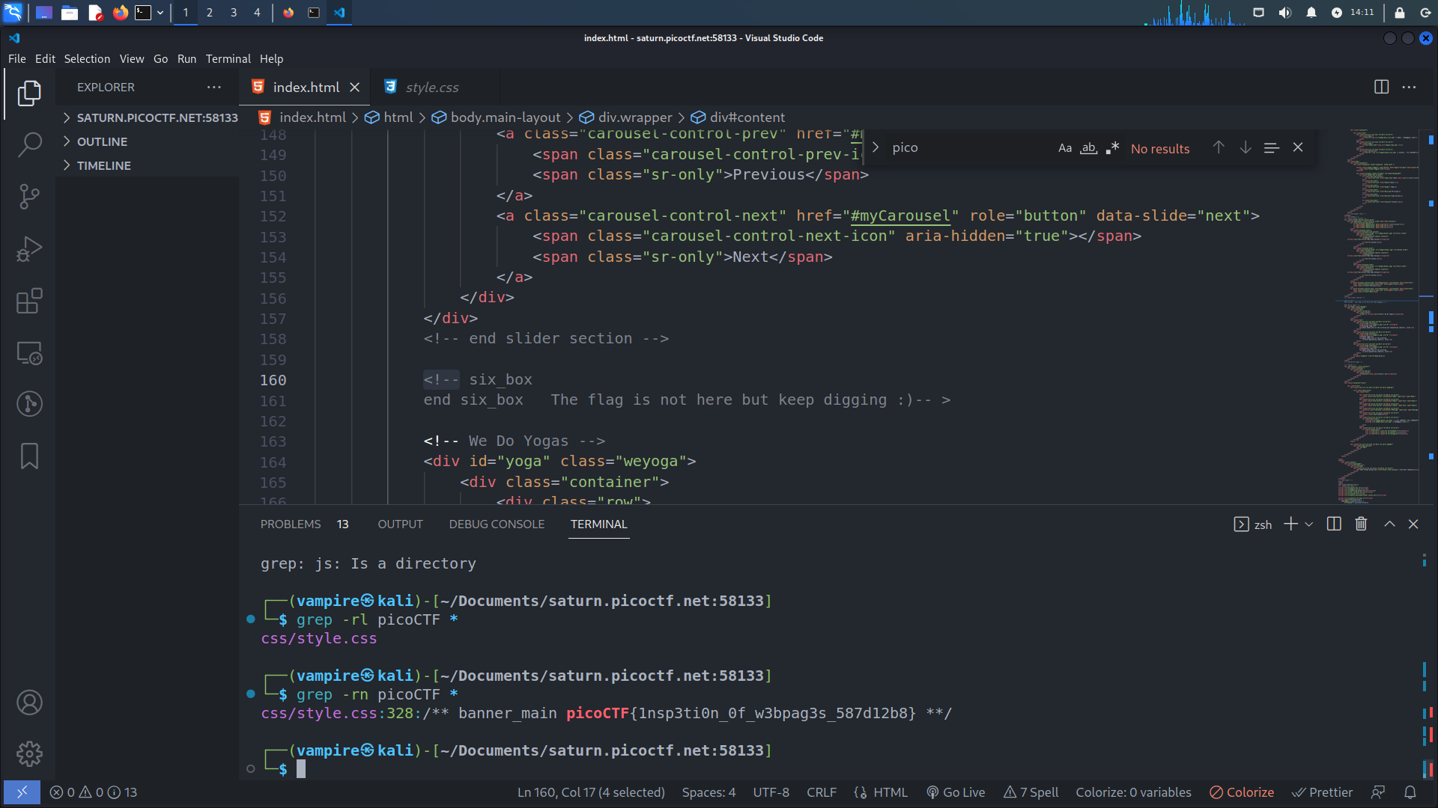

**2- Second way:**

- open webshell of picoctf and download the folder of flag with “ wget <http://saturn.picoctf.net:58133/> ”.

- use ‘grep’ tool to see the picoctf flag with “grep -r picoCTF * ”.

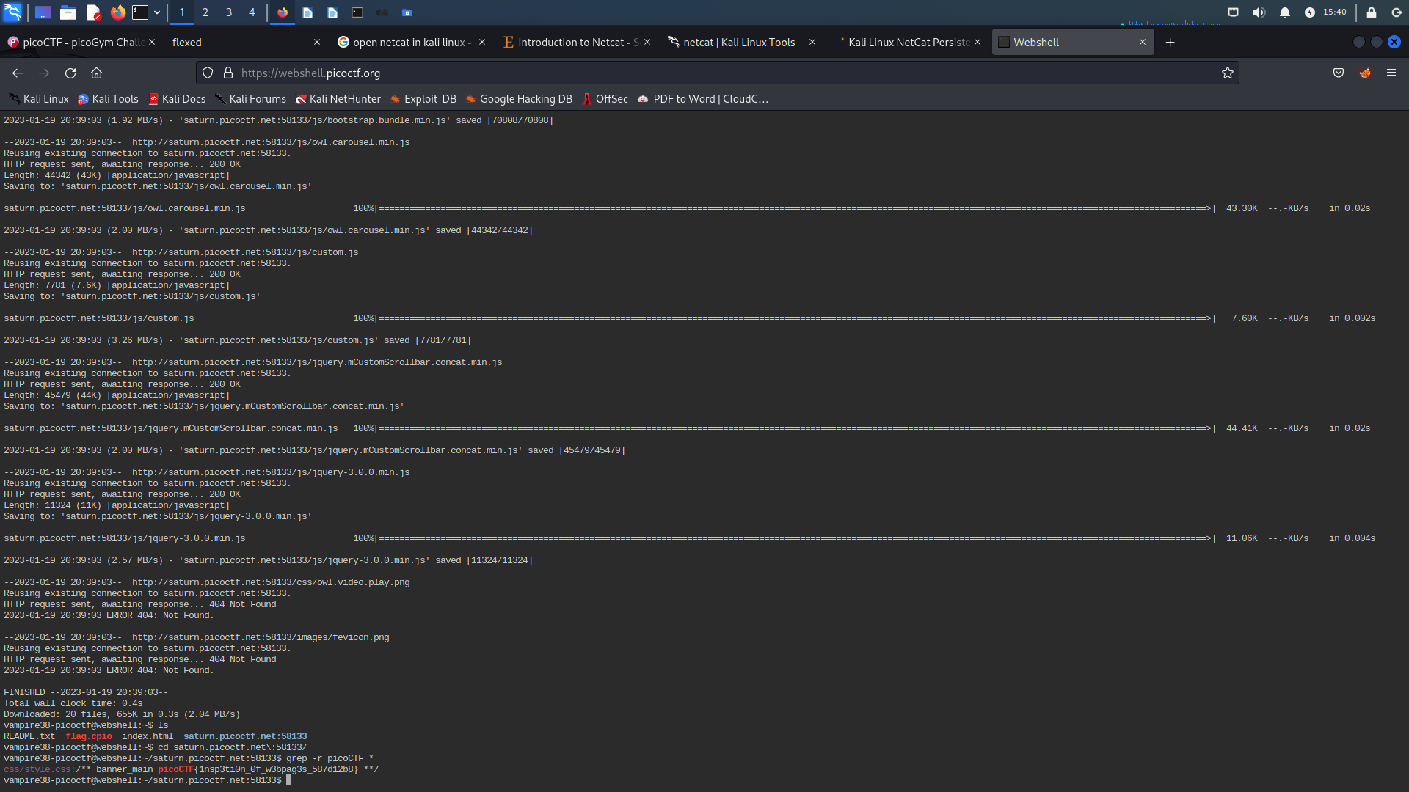

**“Basic-mod1”**

- Download the file open it and found it contains a strings number.

- Use ‘modulus37’ to get the write number then decode this number as say: 0-25 (upper alphabet), 26-35 (decimal digits) and 36 (_).

- Get the picoCTF flag: picoCTF{R0UND_N_R0UND_79C18FB3}

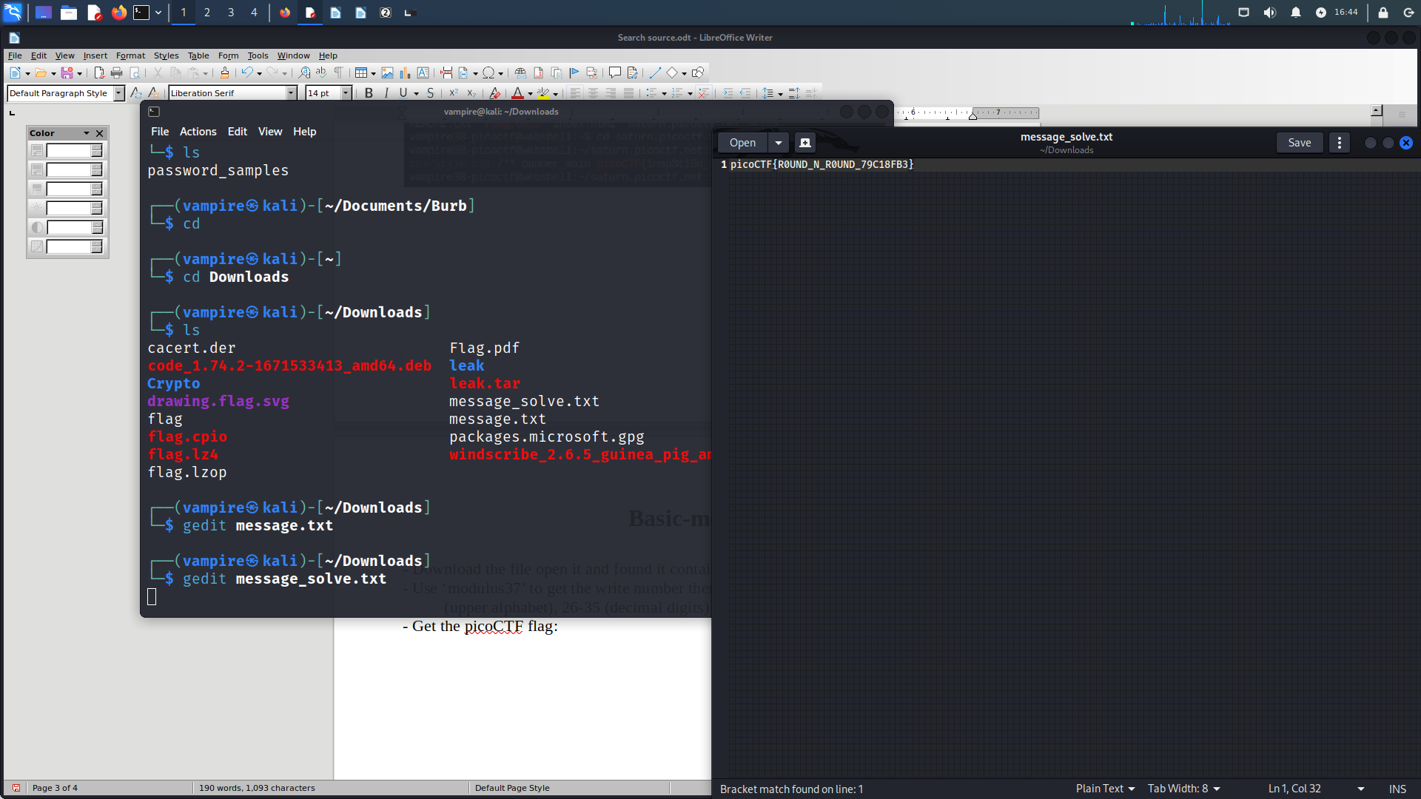



**“Credstuff”**

**-** Download the file then compressed file leak.tar with “tar -xf leak.tar”.

- Get 2 files from leak : 1- username.txt 2- password.txt

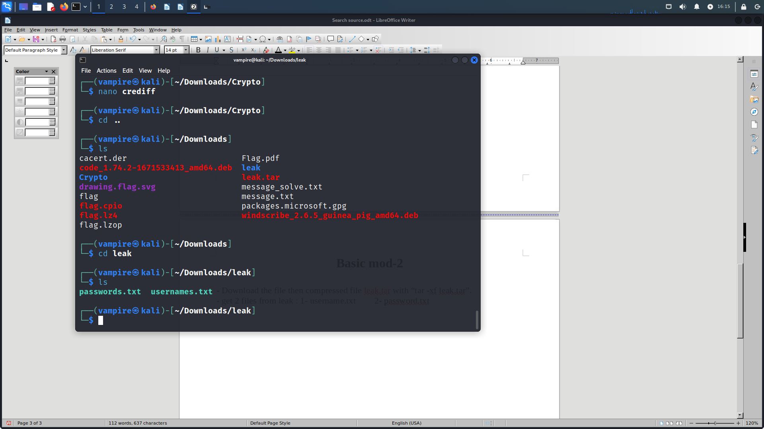

- Open username.txt and search for a name ‘cultiris’ I found it in raw -378-

then open password.txt search on raw -378- I found value had made encoded with rot13. I decoded this value manually with rot13.

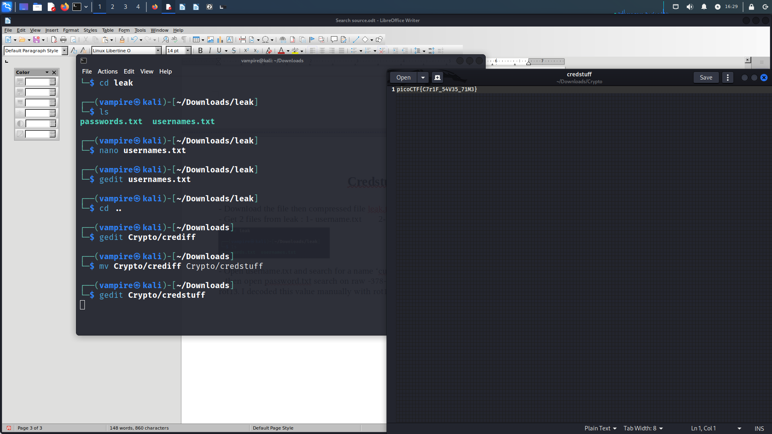

**“Basic-file-exploit”**

- Open web shell for picoctf enter net-cat website:

- Try to see the flag

- Enter “1” for data entry then wrote the data length then choosed “2” for echo if I wrote the data entry with different data I would see the flag:

picoCTF{M4K3_5UR3_70_CH3CK_YOUR_1NPU75_1B9F5942}

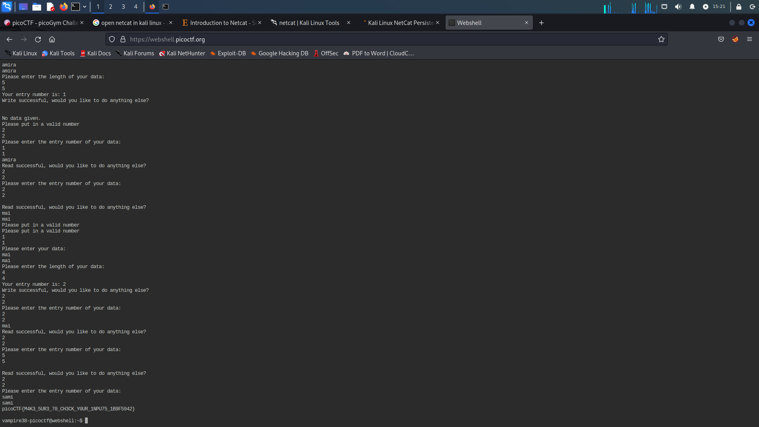

**“Safe Opener”**

- Use wget “<https://artifacts.picoctf.net/c/463/SafeOpener.java>” to download file.

- Find the flag decoded with base64 because it contain upper and lower alphabet also numbers.

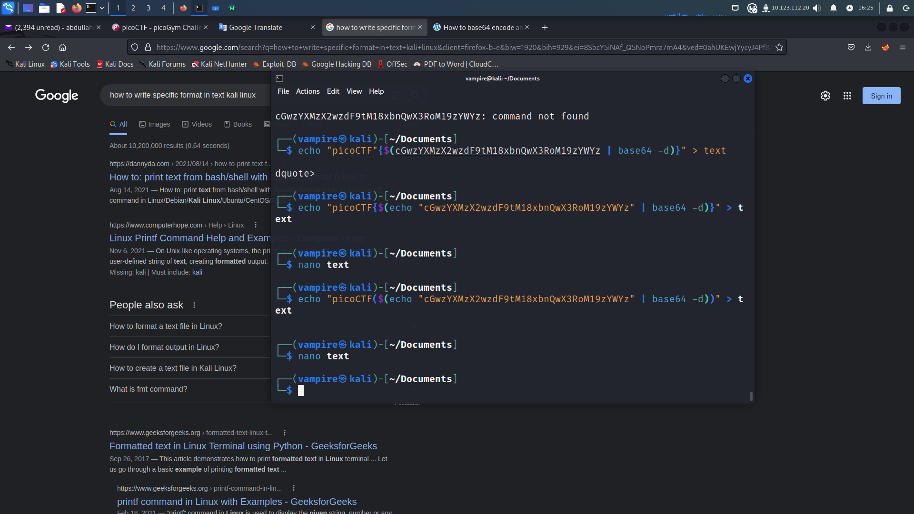

- Open terminal in kali linux to decode base64 and save the flag in text file with the same of flag format.



- Open the file then you see the flag.

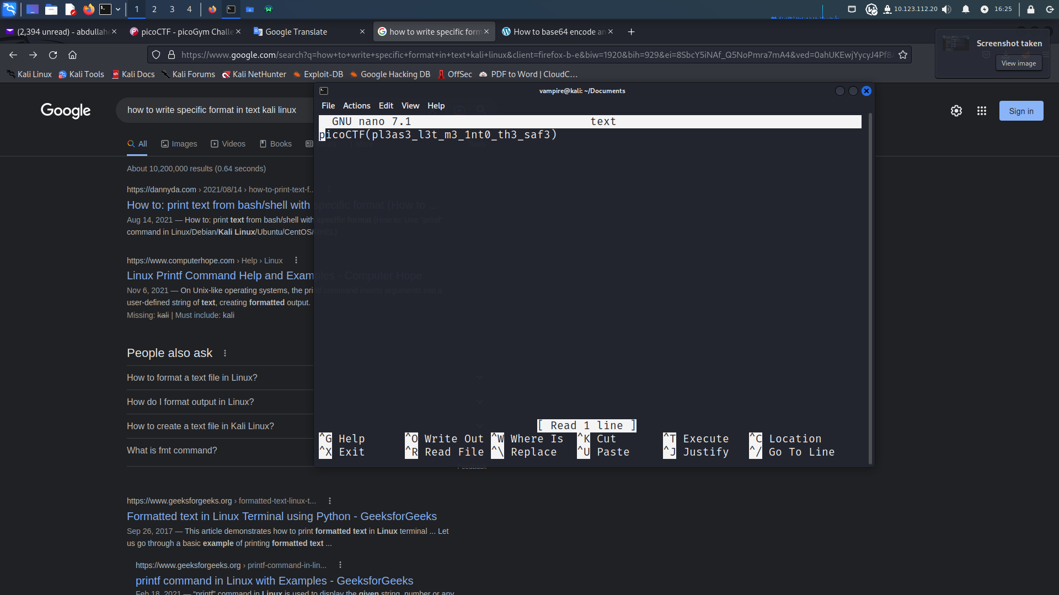

**“Redaction gone wrong”**

- Download PDF file in kali terminal with “wget -q <https://artifacts.picoctf.net/c/264/Financial_Report_for_ABC_Labs.pdf>”

- Open the PDF file, you will see redaction text if you press with mouse you will see the mouse cursor change and become texting only in 2 lines:

* + First redacted line contain: Breakdown.

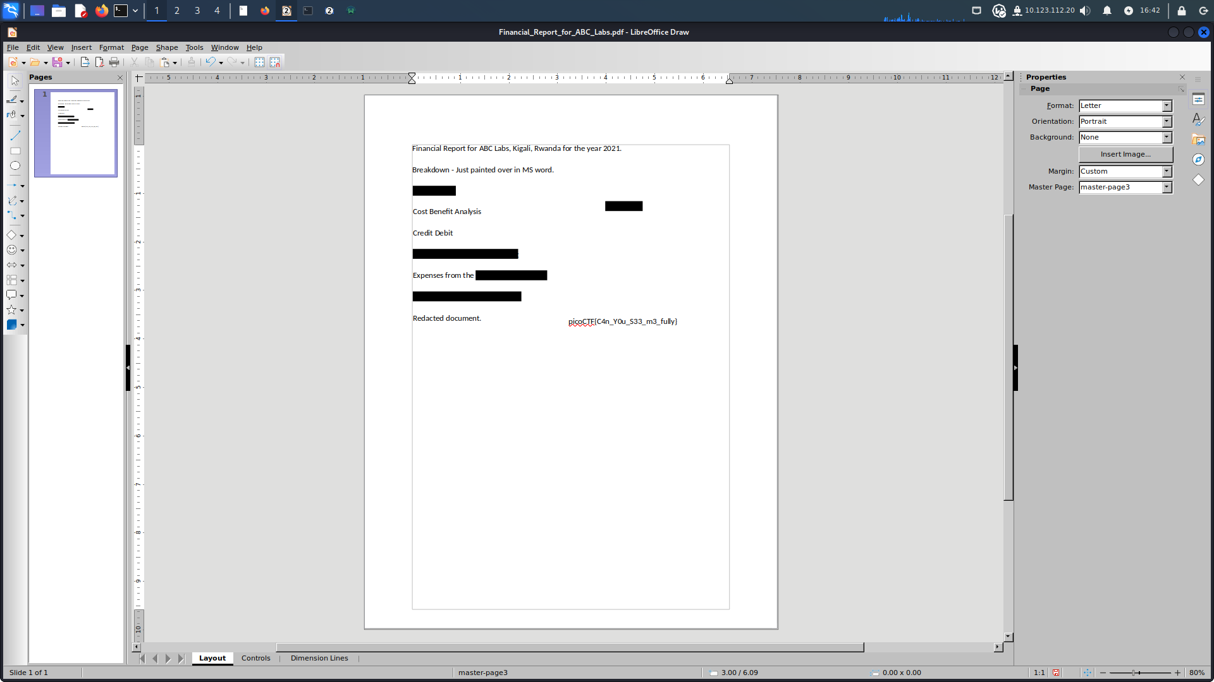

* + Second redacted line contain: The flag.
* 

**“Fresh Java”**

- Open vscode and use terminal with “wget -q <https://artifacts.picoctf.net/c/207/KeygenMe.class>” to download file.

- Find the file in java don’t open, download extension de-compiler in vscode.

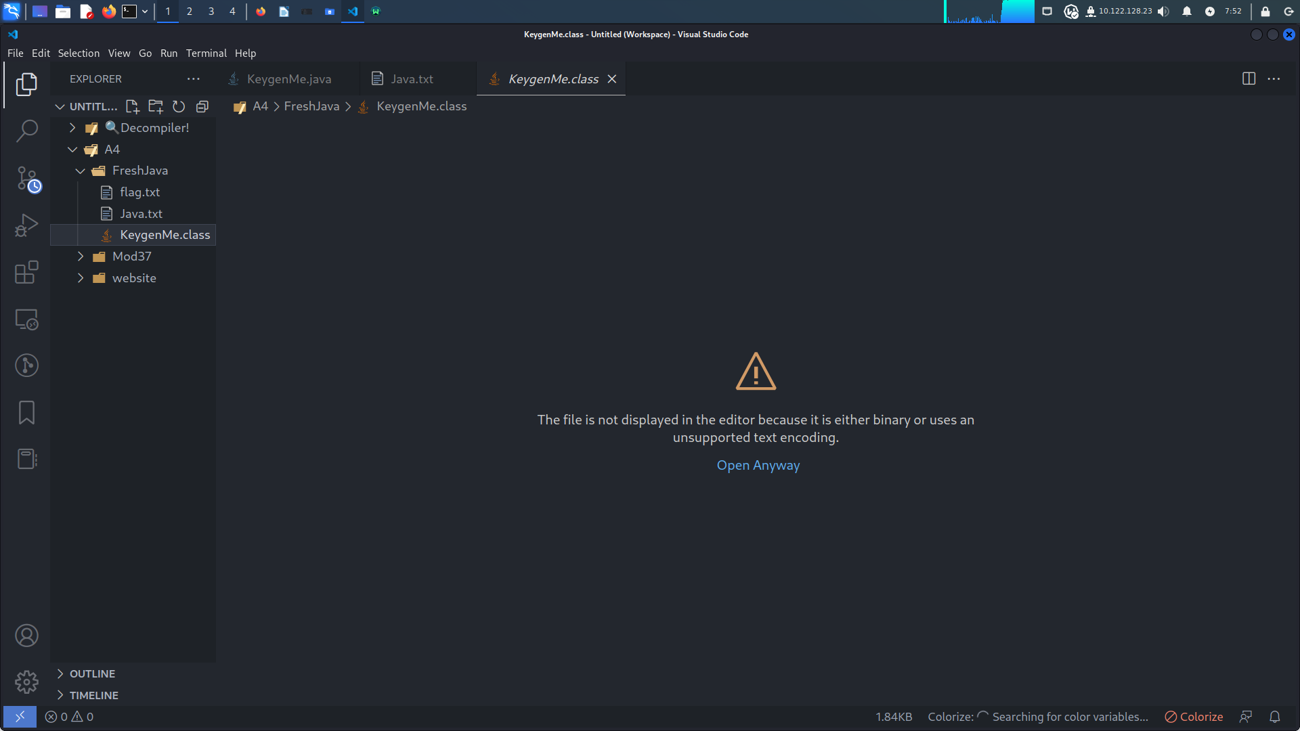

- Copy the code from de-compiler into Java.txt.

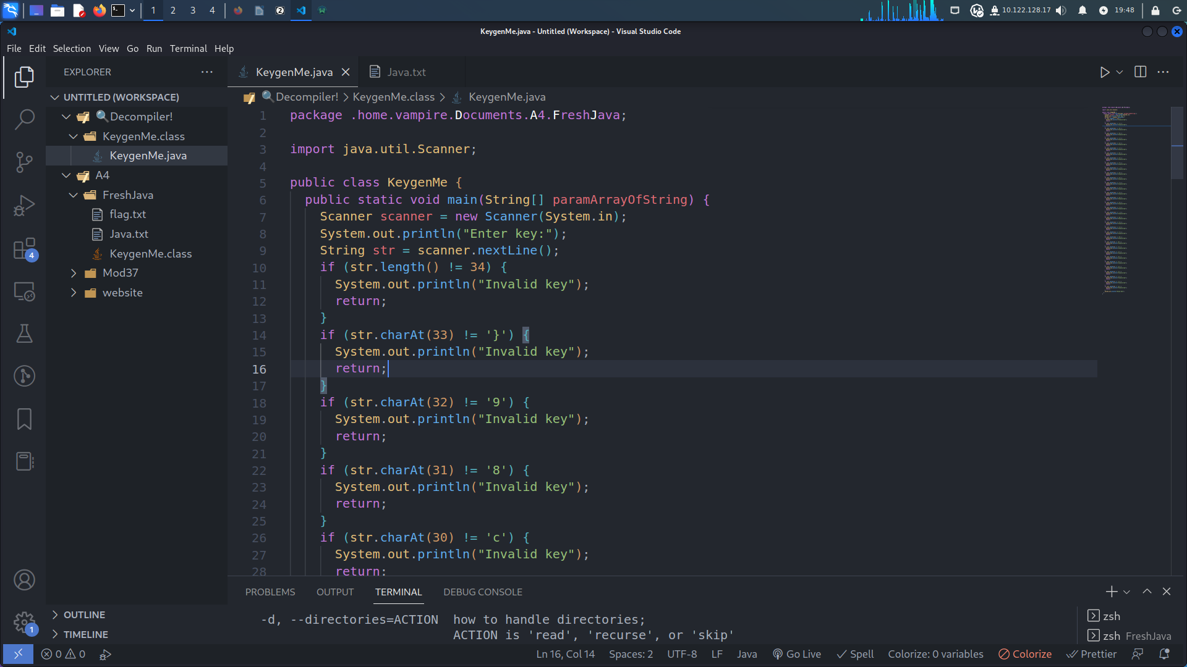

- Open terminal in vscode use grep tool to find the flag with removing all unwanted strings then print the flag in flag.txt.

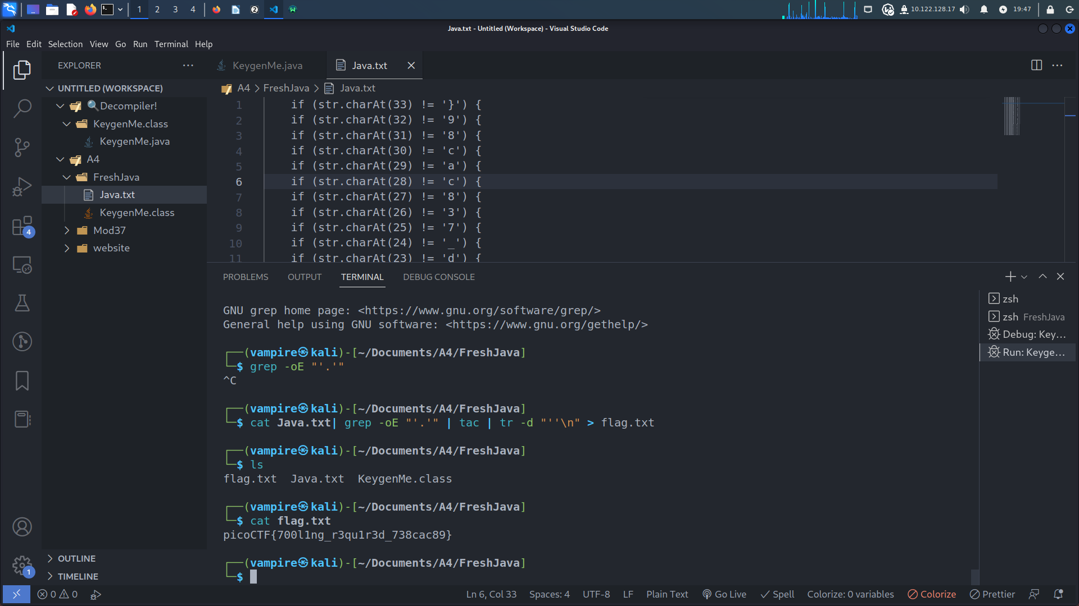

* 

**“SQLilite”**

- Press on launch instance then login.

- Try to write any password with user name admin as example:

Username: admin Password: password

- Open burb suite or press login in your browser then send the request of website into repeater to show what happened in the response. You will show Login failed.

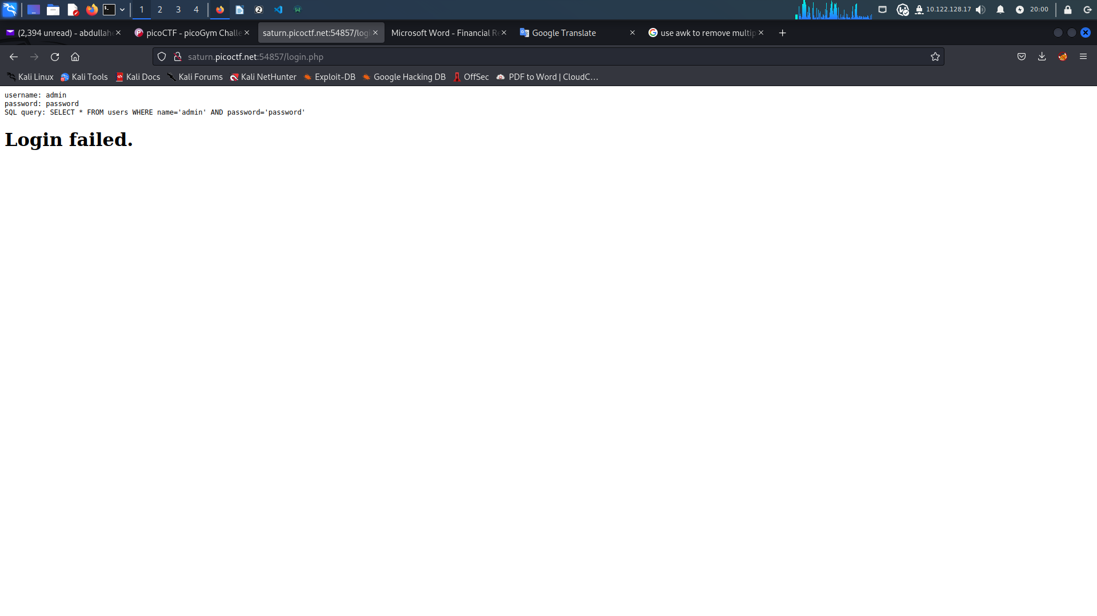

- Take the request again to intruder to make SQL injection attack with loading the library of payloads.

- Show the response, you will found response with three values:

500 response: only see the user name and password that you entered.

200 response: show 2 output

First: Login failed

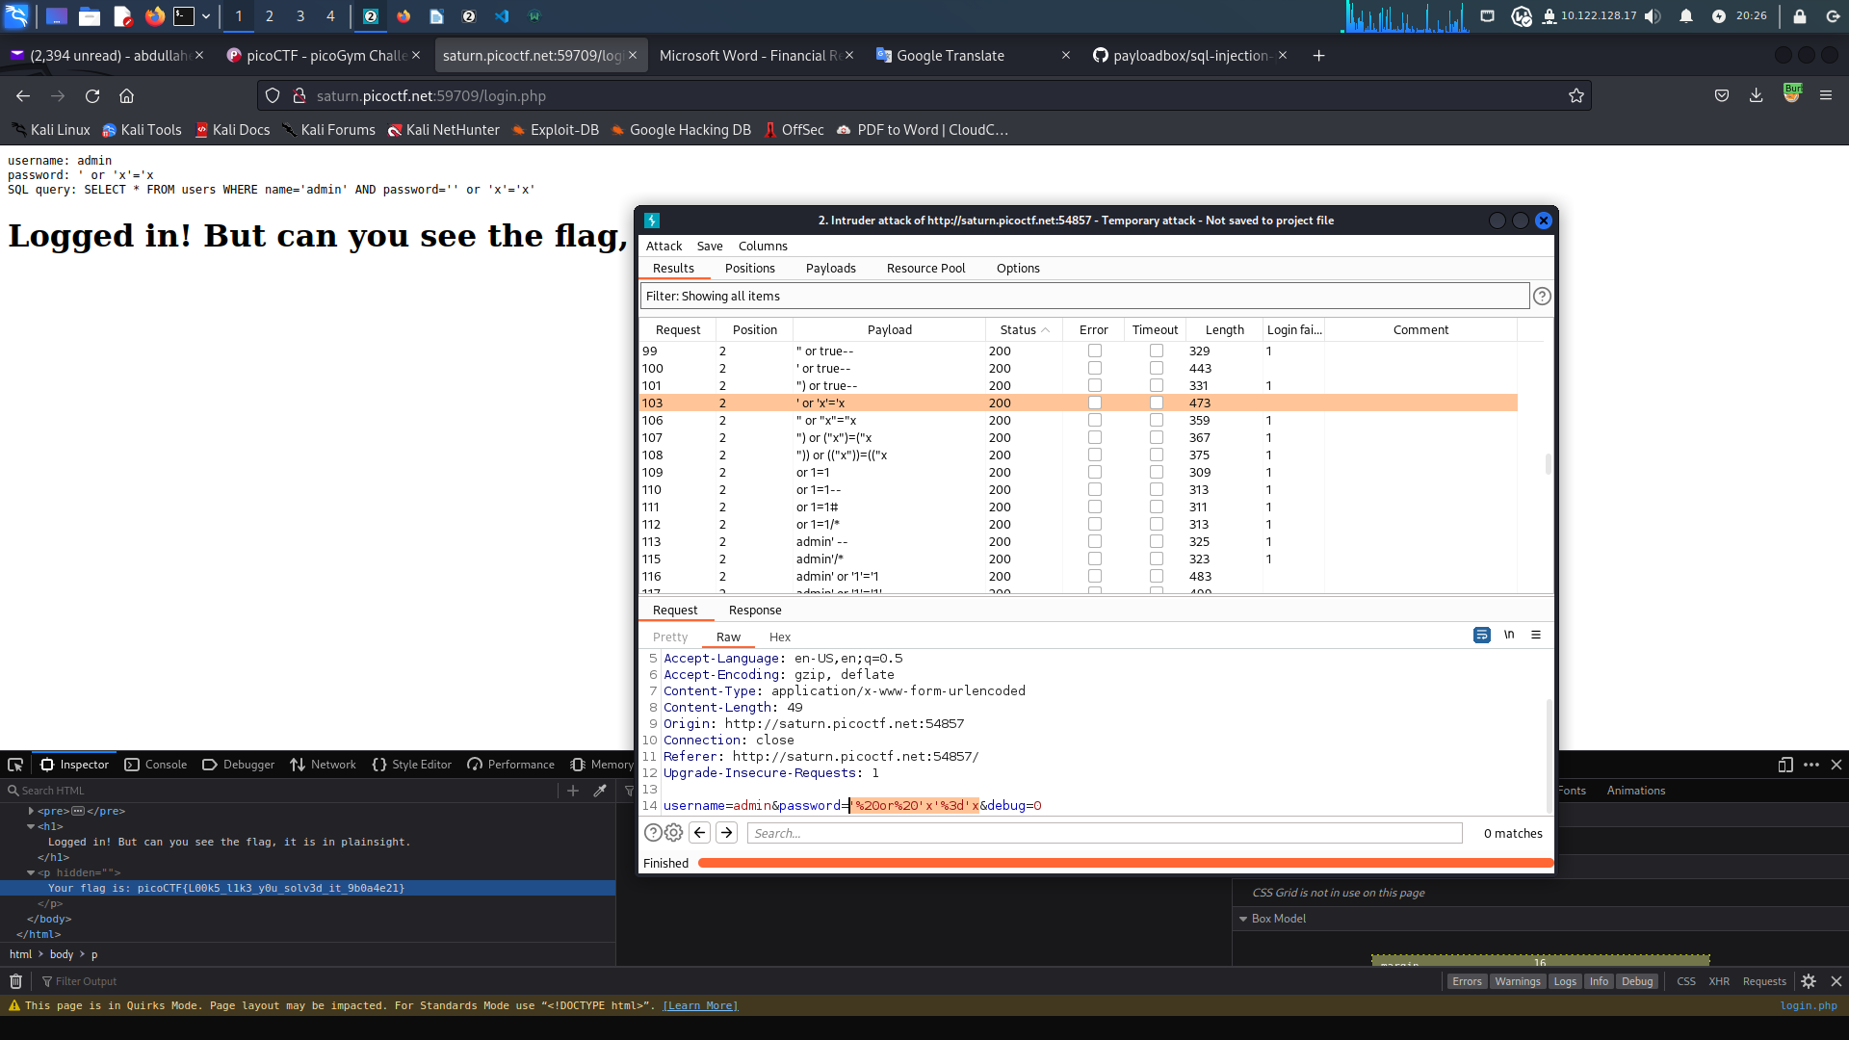

Second: Login success but the flag in plain text if you search carefully, you will find the flag in response at message replied.



 